Gables G7501-01 B737 Nav GLS Panel

https://www.gableseng.com/product/nav-gls-2/

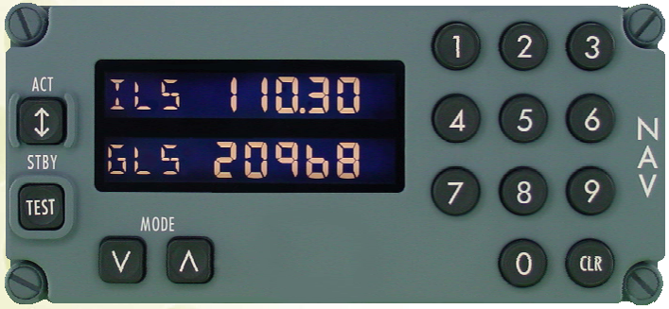
Panel Sizing
Overall dimensions: 2.625” Height x 5.75” Wide (for the backplate). Based on the document “DZUS Rhythm” we know that the DSUZ fasteners are spaced in multiples of 3/8” (0.375”), so we can extrapolate that the fasteners here are at 2.25” apart center to center.
All panels in the center pedestal are 5.75” wide (width of the aluminum backplate).
The Faceplate typically is 1/32” smaller all the way around (1/16 overall), so 2.625 - .03125 Height x 5.75 - .03125 Wide. This comes out to a faceplate size of 2.59375” Height x 5.71875” Wide.
The center to center dimensions for the DZUS fasteners are 2.25” vertically, and 5.375” horizontally.
“Aluminum” backplate dimensions: 2.61” vertically, and 5.735” horizontally.

The OLED Display
This 2.42” 128x64 OLED LCD SSD1309 Display appears as though it would fit the display opening quite nicely. Here’s a screen grab of the dimensional information:
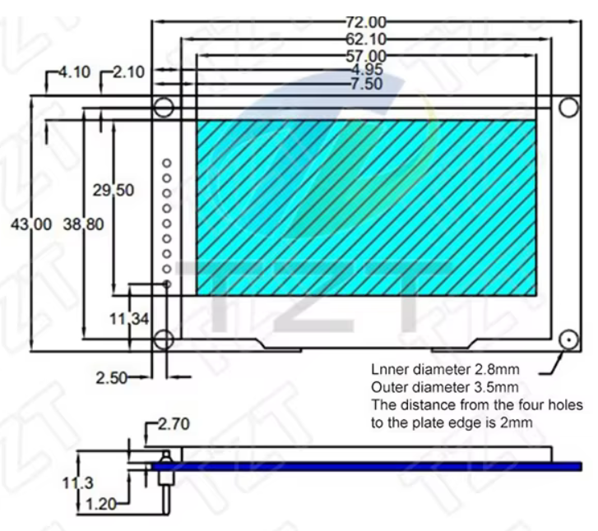
As can be seen, the display (viewable area) measures 2.244” wide x 1.16” tall. The discrepancies between the display size and the opening size can be filled with 3D printed bezel.

Planning the Custom Device
In terms of a first custom device program, this one should be fairly easy.
I will need:
- A font that looks like 7-segment displays - Complete
- To create custom characters for the following: VOR, ILS, GLS, LVP
- On-board RP2040 design
- The only output is the display
- 15 button inputs.
- Ability for screen to go dark via MF sim dataref.
  - Maybe control screen power via another GPIO?
  - Maybe use the U8g2.setPowerSave(1) and (0) command?
  - This screen does not appear to support u8g2.setContrast(value).

Simulator Integration
The nav radio in the zibo appears to be referred to as the “mmr”. Datarefs are tied to mmr.
laminar/B738/mmr/cpt/act_value for example is the dataref for the captain’s mmr active frequency value.
Datarefs below are untested:
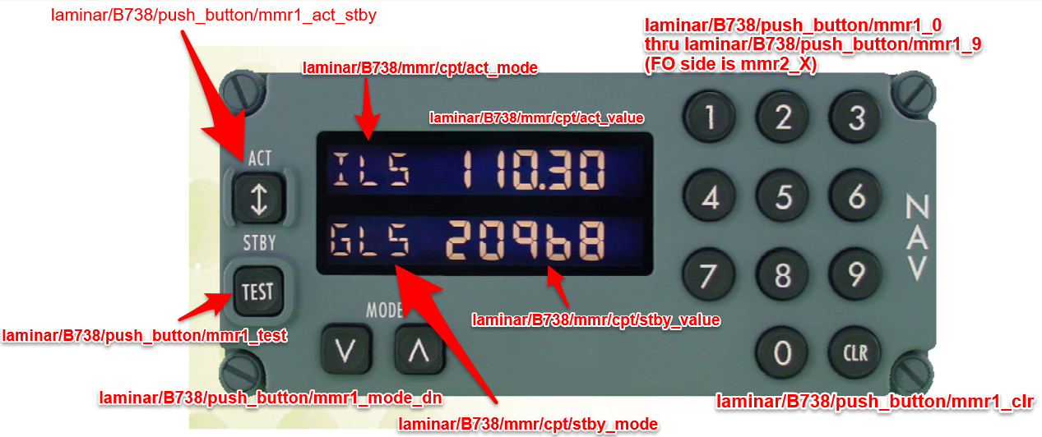

Code Considerations for Formatting the Display

Active Frequency Formatting
ILS & VOR frequencies display a decimal point. GLS/LVP do not. Between VOR & ILS, the greatest frequency value is roughly 117.50Mhz. Specify formatting of sim value based on this. If statement, value greater than 12000 no decimal.

Standby Frequency Display & Formatting
The dataref for the standby frequency displays the entries

Display Information
The display I purchased uses I2C protocol.
Chip: SSD1309
4-Pin Connection
1 GND
2 VDD (3.3V)
3 SCL (Clock)
4 SDA (Data)
The address of the display appears to be 0x3C * 2, or 0x78 (in hex).
This is a 3.3V display. 128 x 64 pixels.
Each pixel is 0.4mm (0.0157”) square. The pitch of the pixels (distance from top of one pixel to top of next pixel) is 0.43mm (0.0169”).
If typical digit size for cockpit panels is 0.36”, my text height should be (.36” / .0169”) = 21 pixels. This actually works out to a digit height of .3549”. This will be a starting point and may need tweaked depending on visual preference.
Display “active” area is 55.02mm (2.166”) wide x 27.5mm (1.083”) tall.
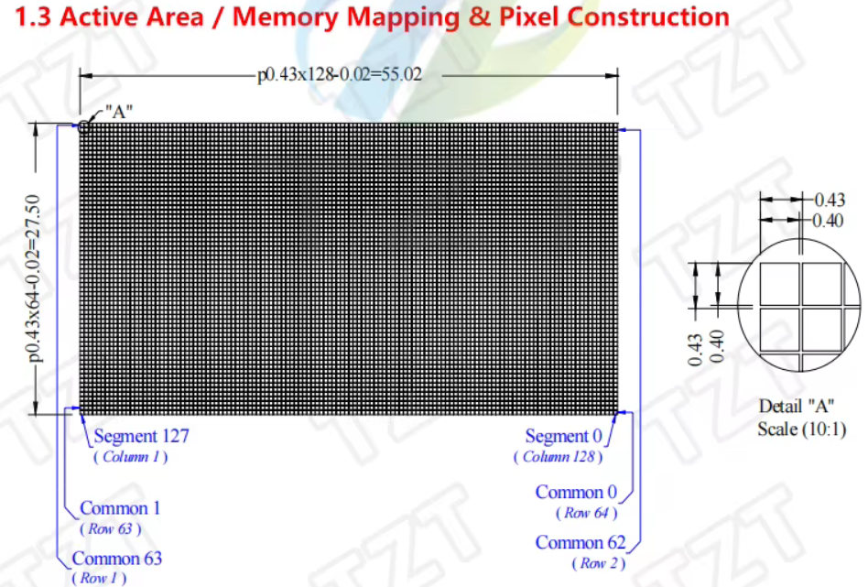

The Code

Helpful Notes for designing the Code
In the C++, note that calling out pins is referring to the GPIO number of the RP2040, NOT the actual device pin number! Example: Wire.setSDA(4); means SDA is connected to GPIO4, which is actually pin 6.
In the U8g2 library, text coordinates refer to the baseline (the bottom) of the text, not the top. If you draw at y = 0, your text will be off-screen. Usually, you start at y = 10 for the top line.

Notes for the Electronics
Illuminated white tactile switches are aliexpress versions of the TS29-1212-1-WT-300-D switches by Same Sky. V_{f} = 3.2V typ. I_{f} = 20mA typ. Marked leg on LED is the cathode pin (short pin, negative).

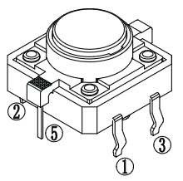
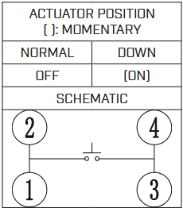
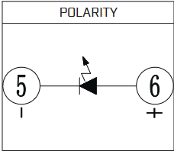
Things Left To Do
Add 4-pin 2.54mm pitch header for connecting OLED to main PCBA. Determine what the connection method between these two boards will be.
Add mounting holes in PCB to attach to panel back plate.
Determine LEDs for the minimal backlighting of panel text.
Find a solution to opening in back plate behind the “MODE” text.

